HOME NON-INVASIVE BLOOD PRESSURE (NIBP) MONITOR
Software Unit Tests

Introduction
This document contains the detailed software tests that must be passed

Unit Tests
SwTestReq1: Peak Detection
Code Unit to Test: Peak-Valley-Noise.vi
Outputs
OUT | CHECK | State | String | Valley

Input Array
IN | SET | Slope | Double Float | 4
IN | SET | Last Slope | Double Float | -9
IN | SET | Pulse | Boolean | FALSE
IN | SET | Heart Rate Timer | I32 | 500

Outputs
OUT | CHECK | State | String | Peak

Input Array
IN | SET | Slope | Double Float | -5
IN | SET | Last Slope | Double Float | 4
IN | SET | Pulse | Boolean | TRUE
IN | SET | Heart Rate Timer | I32 | 500

- Peak-Valley-Noise.vi has the following inputs:
    - Slope – this is the rate at which the pressure is changing between the two most recent points
    - Last Slope – this is the rate at which the pressure is changing between the previous two points
    - Heart Rate Timer– this corresponds to the number of data-points that have been analyzed since the previous valley. If the number of samples is less than 300, it should return ‘Noise’
    - Pulse – set to True after a Valley and until a Peak
    - error in (no error) – if an error is passed into this VI, it should return the same error and zeros for both indicators.
  - Peak-Valley-Noise.vi has the following outputs:
    - State – the options are Peak, Valley or Noise
    - error out – if invalid inputs are received by this VI, it will output an error. It will also pass any errors that are input to it.

SwTestReq3: Blood Pressure Computation
Code Unit to Test: Calculate Blood Pressure.vi
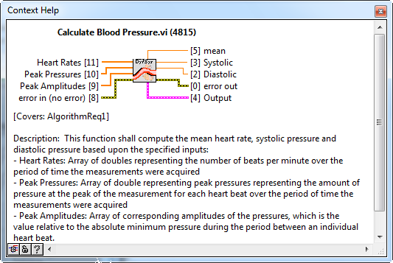
Description: This test will provide defined inputs for the peak amplitudes and test the routine to ensure it correctly calculates the blood pressure
Outputs
OUT CHECK Systolic[Ctr] Double Float 125 symmetric tolerance
OUT CHECK Systolic[Dev] Double Float 3 symmetric tolerance
OUT CHECK Diastolic[Ctr] Double Float 90 symmetric tolerance
OUT CHECK Diastolic[Dev] Double Float 3 symmetric tolerance
Input Array
IN SET Peak Pressures[0]/ Double Float 126.9683093
IN SET Peak Pressures[1]/ Double Float 123.5255625
IN SET Peak Pressures[2]/ Double Float 119.9773799
IN SET Peak Pressures[3]/ Double Float 117.0010526
IN SET Peak Pressures[4]/ Double Float 113.7691773
IN SET Peak Pressures[5]/ Double Float 110.5837654
IN SET Peak Pressures[6]/ Double Float 107.7352118
IN SET Peak Pressures[7]/ Double Float 104.8947001
IN SET Peak Pressures[8]/ Double Float 102.1051191
IN SET Peak Pressures[9]/ Double Float 99.71315615
IN SET Peak Pressures[10]/ Double Float 96.95127445
IN SET Peak Pressures[11]/ Double Float 94.29661525
IN SET Peak Pressures[12]/ Double Float 92.0279588
IN SET Peak Pressures[13]/ Double Float 89.89243705
IN SET Peak Pressures[14]/ Double Float 87.5505115
IN SET Peak Pressures[15]/ Double Float 85.3497628
IN SET Peak Pressures[16]/ Double Float 83.31252845
IN SET Peak Pressures[17]/ Double Float 81.19487765
IN SET Peak Pressures[18]/ Double Float 79.1630047
IN SET Peak Pressures[19]/ Double Float 76.9926356
IN SET Heart Rates[0]/ Double Float 51.28205128
IN SET Heart Rates[1]/ Double Float 65.57377049
IN SET Heart Rates[2]/ Double Float 65.64551422
IN SET Heart Rates[3]/ Double Float 68.02721088
IN SET Heart Rates[4]/ Double Float 66.15214994
IN SET Heart Rates[5]/ Double Float 64.3776824
IN SET Heart Rates[6]/ Double Float 66.74082314
IN SET Heart Rates[7]/ Double Float 66.81514477
IN SET Heart Rates[8]/ Double Float 64.44683136
IN SET Heart Rates[9]/ Double Float 67.87330317
IN SET Heart Rates[10]/ Double Float 68.02721088
IN SET Heart Rates[11]/ Double Float 66.88963211
IN SET Heart Rates[12]/ Double Float 70.01166861
IN SET Heart Rates[13]/ Double Float 72.20216606
IN SET Heart Rates[14]/ Double Float 72.63922518
IN SET Heart Rates[15]/ Double Float 74.71980075
IN SET Heart Rates[16]/ Double Float 75.37688442
IN SET Heart Rates[17]/ Double Float 72.20216606
IN SET Heart Rates[18]/ Double Float 72.99270073
IN SET Heart Rates[19]/ Double Float 72.28915663
IN SET Peak Amplitudes[0]/ Double Float 0.85688945
IN SET Peak Amplitudes[1]/ Double Float 1.05435805
IN SET Peak Amplitudes[2]/ Double Float 1.03202005
IN SET Peak Amplitudes[3]/ Double Float 1.26254885
IN SET Peak Amplitudes[4]/ Double Float 1.4198089
IN SET Peak Amplitudes[5]/ Double Float 1.42517025
IN SET Peak Amplitudes[6]/ Double Float 1.60566195
IN SET Peak Amplitudes[7]/ Double Float 1.5726017
IN SET Peak Amplitudes[8]/ Double Float 1.5663471
IN SET Peak Amplitudes[9]/ Double Float 1.50380045
IN SET Peak Amplitudes[10]/ Double Float 1.6682089
IN SET Peak Amplitudes[11]/ Double Float 1.74594525
IN SET Peak Amplitudes[12]/ Double Float 1.5967267
IN SET Peak Amplitudes[13]/ Double Float 0.8676113
IN SET Peak Amplitudes[14]/ Double Float 0.80863895
IN SET Peak Amplitudes[15]/ Double Float 0.6183187
IN SET Peak Amplitudes[16]/ Double Float 0.4976924
IN SET Peak Amplitudes[17]/ Double Float 0.5334339
IN SET Peak Amplitudes[18]/ Double Float 0.43067835
IN SET Peak Amplitudes[19]/ Double Float 0.3868958
IN SET error in (no error)/status Boolean FALSE
IN SET error in (no error)/code I32 0
IN SET error in (no error)/source String
SwTestReq4: Peak-Valley Noise Valid Inputs
Code Unit to Test: Peak-Valley-Noise.vi
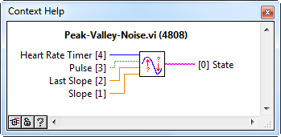
Description: This test shall test the Peak-Valley-Noise.vi to make sure it detects the right state of the signal during point-by-point analysis.
Inputs
Heart Rate Timer > 300
Last Slope = 1
Slope = -1
Pulse = True
Output
State = Peak
Inputs
Heart Rate Timer > 300
Last Slope = 0
Slope = -1
Pulse = False
Output
State = Noise
Inputs
Heart Rate Timer > 300
Last Slope = -1
Slope = 1
Pulse = False
Output
State = Valley

